==+

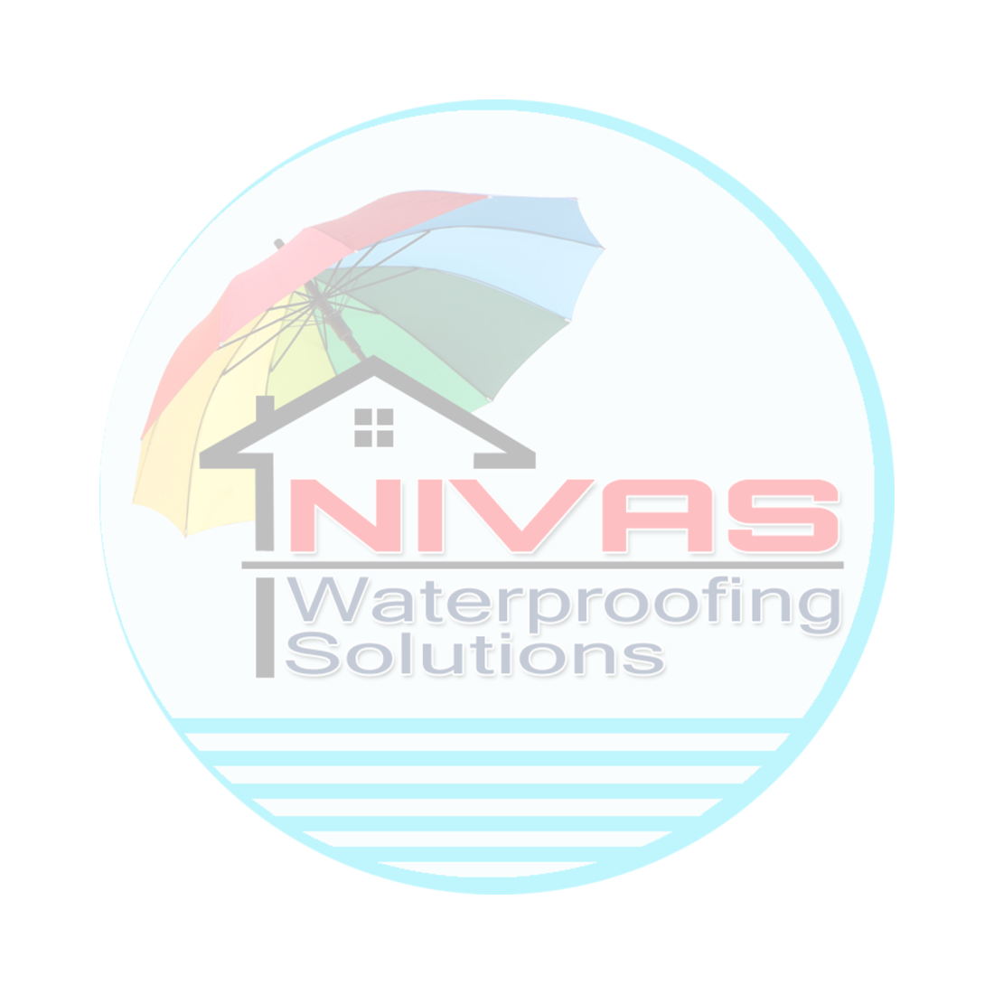

AWC/C/78/2024-25 Date: 28-12-2023.

To,

The Executive Engineer,

(Engineer In-charge)

TSMSIDC,

Hyderabad Division.

Sub: Proposal for Waterproofing at Gandhi Hospital.

Ref: Your inquiry dated 11-12-2023.

Dear Madam,

We are delighted to present our comprehensive proposal for Gandhi Hospital Works, as per your recent inquiry. Enclosed, please find the detailed document containing our competitive prices, which come inclusive of a 5-year warranty. Additionally, we have outlined the CAMC prices separately for the 6th to 10th year.

**Contact Us.**

Srinivas budige

Mob:-09704068010

Email:-nivas.wps@gmail.com

Wabsite:- nivaswps.com

**GST NO: 36BMRPS9372K1ZX**

**PAN NO: BMRPS9372K**

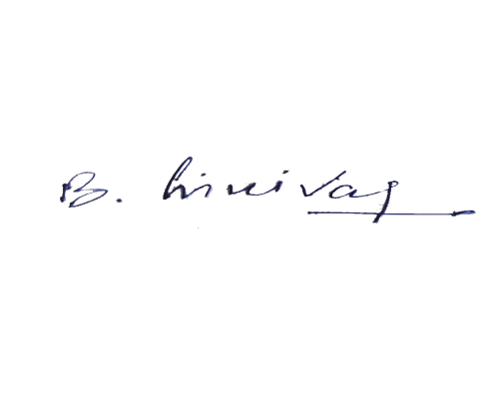**BANK NAME: AXIS BANK**

**BANK TYPE; CURRENT**

**BRANCH: KUSHAIGUDA**

**A/C NO: 918020094476356**

**IFSC CODE: UTIB0003957**

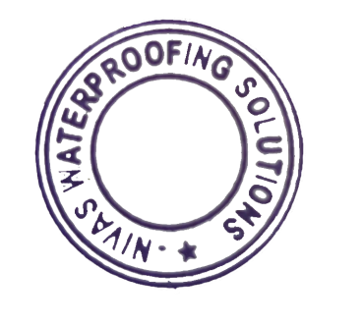 **Nivas waterproofing solutions**

Thanking you in anticipation.